Catchment Delineation and Characterisation

1. Summary
This annexure documents the delineation and characterisation of 2 catchments from a digital elevation model (DEM) with a 10 m x 10 m cell size, using the Catchment Delineation tool (Mayim Tools, version 0.2.0) in total mode. For each catchment it records the inputs and method, the geometric, relief, shape, drainage-network and time-of-concentration parameters, a geomorphological description and general considerations for hydrological assessment and modelling.
Table 1: Summary of delineated catchments
Catchment | Area (km²) | L (km) | S_1085 (%) | S_m (%) | Order | Tc range (min)
Main outlet | 2.094 | 3.401 | 6.77 | 28.5 | 3 | 28.8 - 80.4
Tributary T1 | 0.552 | 1.860 | 5.91 | 27.7 | 2 | 19.1 - 53.0

2. Tool and method
The catchments were delineated with a D8 (eight-direction) flow model (O'Callaghan & Mark 1984), in which every DEM cell drains to the steepest-descent neighbour of its eight neighbours. The processing steps were:
- The D8 flow-direction (pointer) raster was decoded and checked; codes that are not valid D8 directions were treated as NoData and reported.
- Flow accumulation (number of upstream cells) was computed in topological order from the pointer.
- Pour points were moved to the cell with the highest flow accumulation within 3 cells, so that they sit on the drainage line. Pour lines were rasterised as a 4-connected chain of cells, so no D8 flow path can cross a line without being counted.
- Every cell was traced downstream to the first outlet cell it reaches. In total mode each catchment includes everything upstream of its outlet, so nested catchments overlap.
- The outline was traced along cell edges. Interior holes (cells inside the outline that do not drain to the outlet) were filled and their area reported. Cells touching only at a corner form separate polygon parts, and the geometry was checked and repaired to a valid (multi)polygon.
- The DEM was clipped to the catchment outlines, and the parameters, longest flow path, stream network and figures in this annexure were derived from the DEM and flow network.

3. Inputs and settings
Table 2: Inputs and processing settings
Item | Value
DEM | D:/Projects/demo/dem_filled.tif
Coordinate reference system | EPSG:32735 - WGS 84 / UTM zone 35S
DEM cell size | 10 m x 10 m
DEM dimensions | 200 columns x 220 rows
D8 pointer | D:/Projects/demo/d8_pointer.tif
Pointer encoding | WhiteboxTools
Outlet layer | pour_points
Outlet features | 2
Outlet name field | name
Pour point snap radius | 3 cells
Catchment mode | Total
Stream threshold | 0.05 km² upstream area
Run | 2026-09-24 10:15

The DEM is assumed to be hydrologically conditioned (pits filled or breached, flats resolved) and in a projected coordinate system in metres. All lengths, areas and slopes are in that system.

4. Parameters and calculations
Table 3: Parameter definitions
Parameter | Symbol (unit) | Definition / equation | Source
Contributing area | A (km²) | Number of cells draining to the outlet x cell area. | -
Polygon area | A_p (km²) | Area of the catchment outline, including filled interior holes. | -
Perimeter | P (km) | Length of the catchment outline, following cell edges. | -
Elevations | z (m) | Minimum, maximum and mean DEM elevation of contributing cells; z_o at the outlet cell. | -
Longest flow path | L (km) | Longest D8 flow path to the outlet, from cell centre to outlet cell centre. | O'Callaghan & Mark (1984)
Centroid distance | Lca (km) | Distance along L from the outlet to the point on L nearest the catchment centroid. | -
Basin length | Lb (km) | Longest straight-line distance from the outlet to any point in the catchment. | -
Average slope | S_avg (m/m) | S_avg = (z_top - z_o) / L, along the longest flow path. | -
10-85 slope | S_1085 (m/m) | S_1085 = (z_85 - z_10) / (0.75 L), elevations at 10 % and 85 % of L from the outlet. | -
Equal-area slope | S_e (m/m) | Slope of the line through the outlet with the same area under it as the profile: S_e = 2 ∫(z - z_o) dx / L². | -
Mean catchment slope | S_m (%) | Mean of the cell slopes (3 x 3 finite-difference method) over the catchment. | Horn (1981)
Form factor | R_f | R_f = A_p / L². | Horton (1932)
Circularity ratio | R_c | R_c = 4π A_p / P². | Miller (1953)
Elongation ratio | R_e | R_e = 2 √(A_p / π) / L. | Schumm (1956)
Compactness coefficient | K_c | K_c = P / (2 √(π A_p)). | Gravelius (1914)
Hypsometric integral | HI | HI = (z_mean - z_min) / (z_max - z_min) (elevation-relief ratio). | Strahler (1952); Pike & Wilson (1971)
Relief ratio | R_h | R_h = H / Lb, with H = z_max - z_o. | Schumm (1956)
Melton ratio | M | M = H / √A (H in km). | Melton (1965)
Ruggedness number | R_n | R_n = H x D_d (H in km). | Strahler (1958)
Streams | - | Cells whose upstream area is at least the stream threshold. | -
Stream order | u | Strahler ordering of the stream cells; the catchment order is the highest. | Strahler (1957)
Bifurcation ratio | R_b | Mean of N_u / N_u+1 over consecutive orders (N_u = number of segments of order u). | Strahler (1964)
Drainage density | D_d (km/km²) | D_d = total stream length / A. | Horton (1932)
Stream frequency | F_s (1/km²) | F_s = number of stream segments / A. | Horton (1932)
Length of overland flow | L_o (km) | L_o = 1 / (2 D_d). | Horton (1945)
Constant of channel maintenance | C (km²/km) | C = 1 / D_d. | Schumm (1956)
Sinuosity | - | L / straight-line distance between its ends. | -
Tc - Kirpich | t_c (min) | t_c = 0.0195 L^0.77 S_avg^-0.385 (L in m). | Kirpich (1940)
Tc - USBR | t_c (min) | t_c = 60 (0.87 L² / (1000 S_1085))^0.385 (L in km). | USBR (1973)
Tc - Bransby-Williams | t_c (min) | t_c = 58 L / (A^0.1 S_e^0.2) (L in km, A in km², S_e in m/km). | Bransby-Williams (1922)

Kirpich uses S_avg, USBR uses S_1085 and Bransby-Williams uses S_e, each with the longest flow path L. None of the three separates overland from channel flow, so they apply the whole path length as channel-type flow.

5. Catchment results

5.1 Catchment Main outlet
Catchment Main outlet drains 2.094 km² (209.4 ha) to a pour point at E 512,715.0, N 6,247,805.0, outlet elevation 1,236.4 m. Elevations range from 1,236.4 m to 1,480.7 m (relief 244.4 m, mean 1,359.1 m). The longest flow path is 3.401 km long, with a 10-85 slope of 6.77 % and an equal-area slope of 6.13 %.
Geomorphological description
Scale. By the classification of Ponce (1989), this is a small catchment (small < 2.5 km², midsize 2.5-250 km², large > 250 km²). For a small catchment, rainfall can usually be taken as uniform in space and time over the catchment, overland flow is a large part of the response and channel storage is small.
Shape. The elongation ratio of 0.48 (Schumm 1956) classes the catchment as more elongated; the form factor is 0.18 (Horton 1932), the circularity ratio 0.22 (Miller 1953) and the Gravelius compactness coefficient 2.13. This shape suggests a flatter, longer hydrograph than a compact catchment of the same area, since travel times from different parts are spread out. The basin length (outlet to the farthest point of the catchment) is 2.302 km. Circularity and compactness use the stepped cell outline, which lengthens the perimeter; treat them as indicative.
Relief and slope. The mean catchment slope is 28.5 %, which is moderately steep in the FAO (2006) classes; 9 % of the area is flatter than 2 % and 72 % is steeper than 15 %. The relief ratio (Schumm 1956) is 0.1061 and the average slope of the longest flow path is 6.72 %. Much of the catchment is steep, so expect high flow velocities and a short time to peak.
Hypsometry. The hypsometric integral is 0.502, which Strahler (1952) associates with a mature (in equilibrium) landscape. Area is spread fairly evenly over the elevation range.
Drainage network. With streams defined as cells draining at least 0.050 km², the network reaches Strahler order 3 with 16 stream segments and 7.31 km of channel: a drainage density of 3.49 km/km² and a stream frequency of 7.64 per km². The mean bifurcation ratio is 4.25; values of about 3 to 5 are typical of networks without strong geological control (Strahler 1964). The mean length of overland flow (Horton 1945) is about 0.143 km. Because the network comes from a DEM threshold, density, order and frequency change with that threshold; compare them between catchments only at the same threshold and resolution.
Main flow path. The longest flow path has a sinuosity of 1.51 (path length over straight-line distance). The distance from the outlet to the point on the path nearest the centroid (Lca) is 2.025 km. D8 paths step between cell centres in eight directions, so they run a few per cent longer than the true channel.
Aspect. The most common slope aspect is S (18 % of the area).
Process screening. The Melton ruggedness ratio is 0.169 and the ruggedness number is 0.853 (Strahler 1958). With the thresholds of Wilford et al. (2004), the catchment screens as flood-prone. That method was calibrated on specific regions and is an indicative screen only.
Hydrological assessment and modelling considerations
- Peak-flow methods that assume uniform rainfall over the catchment (rational-type methods) and single lumped hydrograph methods are generally suitable at this scale, subject to the limits set by the applicable local guideline.
- Time of concentration estimates: Kirpich 28.9 min, USBR 28.8 min, Bransby-Williams 80.4 min. Estimates range from 28.8 to 80.4 min (a factor of 2.8), so the choice of method matters. Each empirical formula is only valid within the conditions it was derived for (Kirpich 1940 comes from small, steep rural catchments), and none of these values separates overland from channel flow. Select or combine methods to suit the catchment and the governing guideline.
- Design storm durations should bracket the critical duration; as a starting range, test from about 14 min to 161 min. For hydrograph models, use a computational time step of no more than about 0.1 to 0.2 x Tc, i.e. 2.9 to 5.8 min here (compare the unit hydrograph guidance of USDA-NRCS 2007, dt <= 0.29 x lag).
- Check the delineated boundary against imagery, survey and drainage infrastructure. Culverts, bridges, embankments and urban drainage are not in a bare-earth DEM and can move the divide.
Table 4: Parameters of catchment Main outlet
Parameter | Value
Geometry
Contributing area A (km²) | 2.0938
Contributing area (ha) | 209.38
Polygon area A_p (km²) | 2.0938
Filled interior holes (ha) | 0.00
Perimeter P (km) | 10.920
Polygon parts | 1
Centroid E | 512735.3
Centroid N | 6249038.7
Outlet
Outlet type | point
Outlet E | 512715.0
Outlet N | 6247805.0
Snap distance (m) | 0.0
Outlet cells | 1
Drains into | -
Elevation and relief
Outlet elevation z_o (m) | 1236.37
Minimum elevation (m) | 1236.37
Maximum elevation (m) | 1480.73
Mean elevation (m) | 1359.10
Relief z_max - z_min (m) | 244.36
Hypsometric integral HI | 0.502
Relief ratio R_h | 0.1061
Melton ratio M | 0.169
Ruggedness number R_n | 0.853
Lengths and slopes
Longest flow path L (km) | 3.401
Centroid distance Lca (km) | 2.025
Basin length Lb (km) | 2.302
Sinuosity of L | 1.513
Average slope S_avg (%) | 6.724
10-85 slope S_1085 (%) | 6.771
Equal-area slope S_e (%) | 6.130
Mean catchment slope S_m (%) | 28.47
Shape
Form factor R_f | 0.181
Circularity ratio R_c | 0.221
Elongation ratio R_e | 0.480
Compactness coefficient K_c | 2.129
Drainage network
Highest Strahler order | 3
Stream segments | 16
Stream length (km) | 7.311
Drainage density D_d (km/km²) | 3.492
Stream frequency F_s (1/km²) | 7.642
Bifurcation ratio R_b | 4.25
Length of overland flow L_o (km) | 0.143
Constant of channel maintenance C (km²/km) | 0.286
Time of concentration
Kirpich (min) | 28.9
USBR (min) | 28.8
Bransby-Williams (min) | 80.4

Table 5: Slope class distribution, catchment Main outlet (FAO 2006 classes)
Slope class | Area (%)
0-2 % (level to very gently sloping) | 8.6
2-5 % (gently sloping) | 3.7
5-10 % (sloping) | 6.9
10-15 % (strongly sloping) | 8.2
15-30 % (moderately steep) | 29.5
30-60 % (steep) | 35.9
> 60 % (very steep) | 7.1

Table 6: Aspect distribution, catchment Main outlet
Aspect | Area (%)
N | 6.7
NE | 8.6
E | 12.2
SE | 16.2
S | 17.6
SW | 13.4
W | 11.1
NW | 7.5
Flat | 6.7

Table 7: Stream network by Strahler order, Main outlet
Order u | Segments N_u | Length (km)
1 | 13 | 2.408
2 | 2 | 4.359
3 | 1 | 0.544

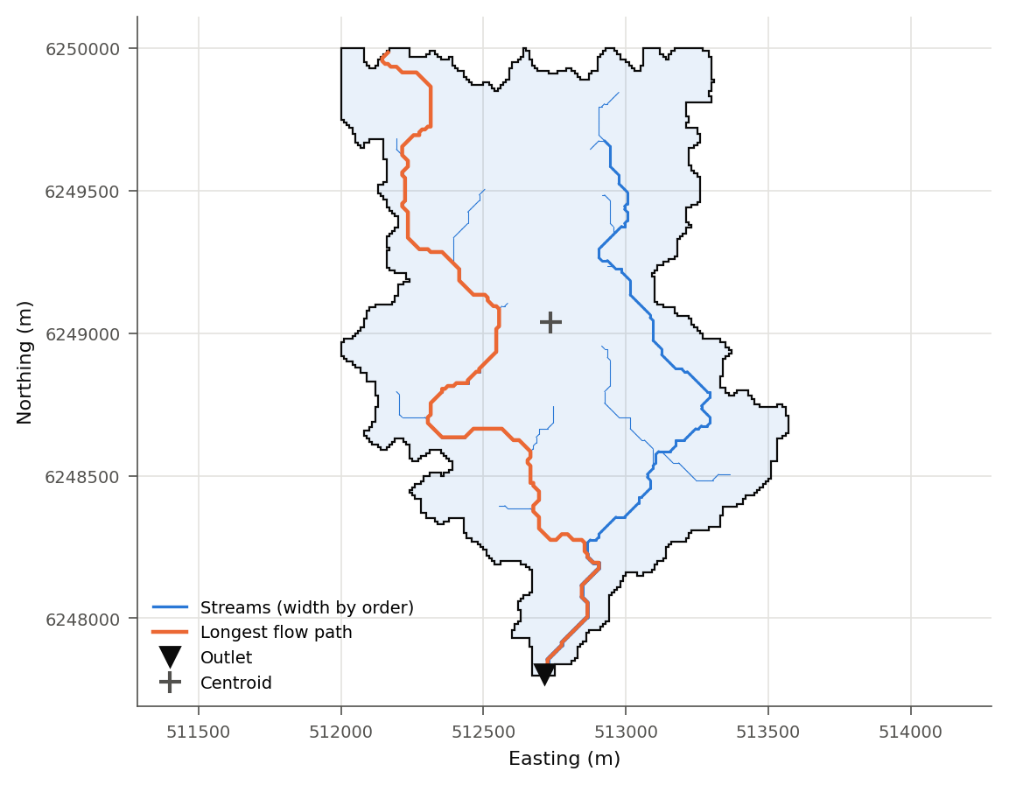
Figure 1: Catchment Main outlet: outline, stream network, longest flow path, outlet and centroid
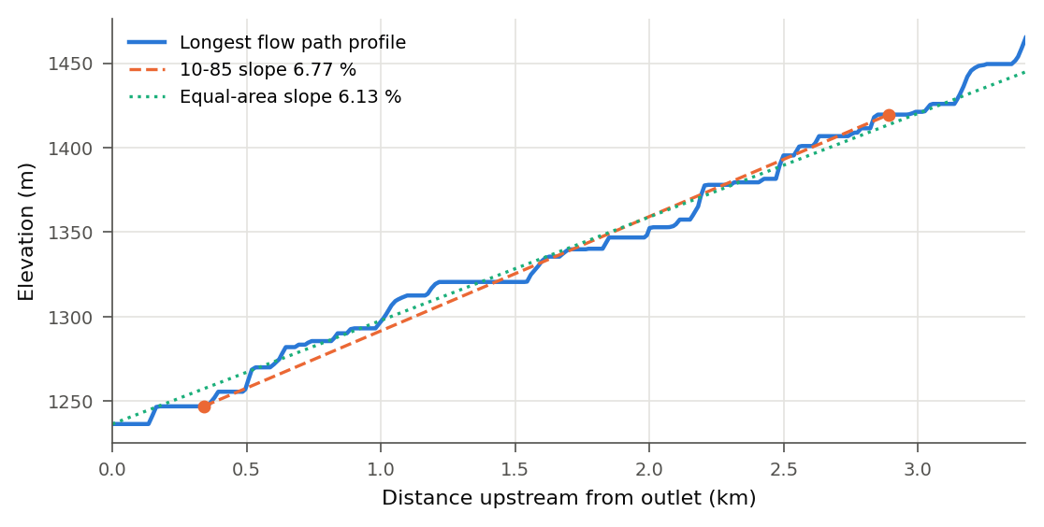
Figure 2: Catchment Main outlet: longitudinal profile of the longest flow path
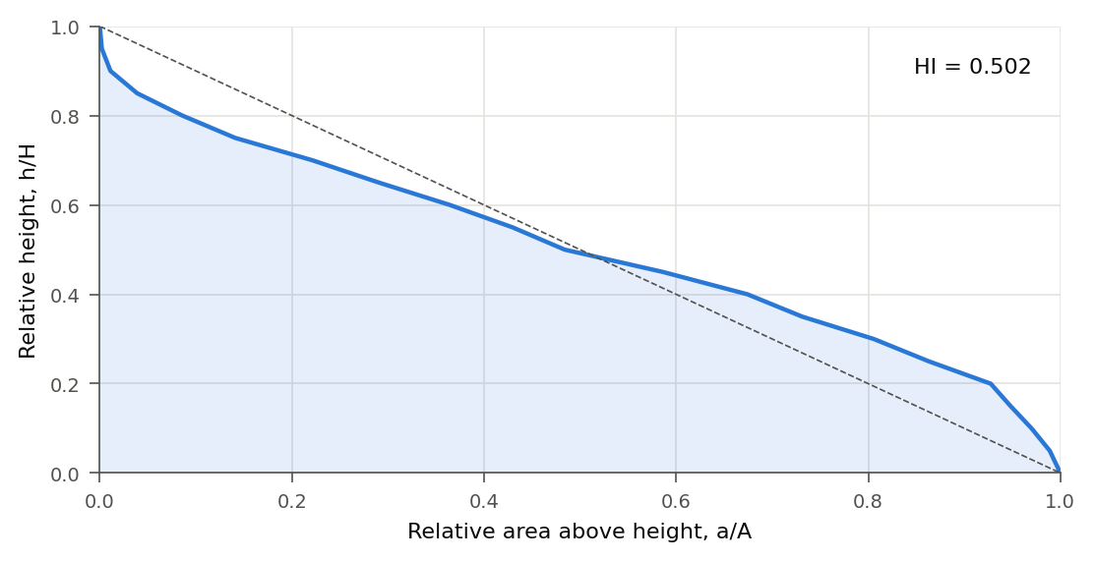
Figure 3: Catchment Main outlet: hypsometric curve
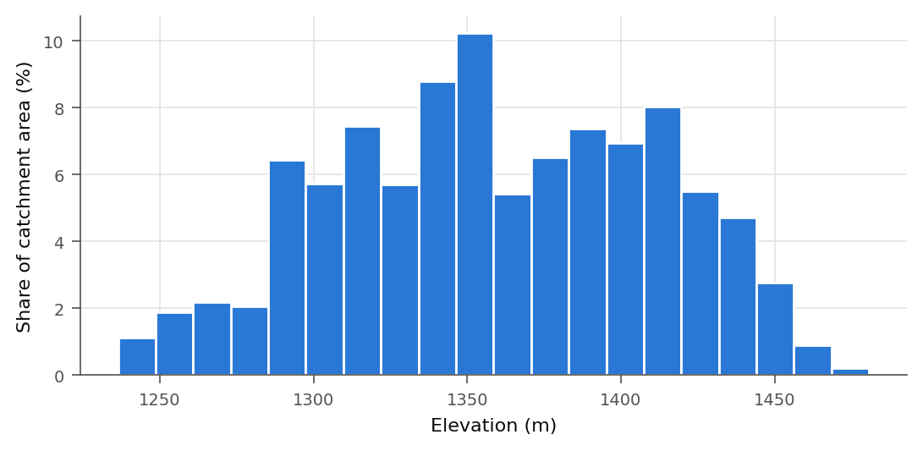
Figure 4: Catchment Main outlet: elevation distribution

5.2 Catchment Tributary T1
Catchment Tributary T1 drains 0.552 km² (55.2 ha) to a pour point at E 513,295.0, N 6,248,785.0, outlet elevation 1,335.8 m. Elevations range from 1,335.8 m to 1,458.2 m (relief 122.3 m, mean 1,394.3 m). The longest flow path is 1.860 km long, with a 10-85 slope of 5.91 % and an equal-area slope of 4.68 %.
Geomorphological description
Scale. By the classification of Ponce (1989), this is a small catchment (small < 2.5 km², midsize 2.5-250 km², large > 250 km²). For a small catchment, rainfall can usually be taken as uniform in space and time over the catchment, overland flow is a large part of the response and channel storage is small.
Shape. The elongation ratio of 0.45 (Schumm 1956) classes the catchment as more elongated; the form factor is 0.16 (Horton 1932), the circularity ratio 0.20 (Miller 1953) and the Gravelius compactness coefficient 2.24. This shape suggests a flatter, longer hydrograph than a compact catchment of the same area, since travel times from different parts are spread out. The basin length (outlet to the farthest point of the catchment) is 1.373 km. Circularity and compactness use the stepped cell outline, which lengthens the perimeter; treat them as indicative.
Relief and slope. The mean catchment slope is 27.7 %, which is moderately steep in the FAO (2006) classes; 9 % of the area is flatter than 2 % and 70 % is steeper than 15 %. The relief ratio (Schumm 1956) is 0.0891 and the average slope of the longest flow path is 5.59 %. Much of the catchment is steep, so expect high flow velocities and a short time to peak.
Hypsometry. The hypsometric integral is 0.478, which Strahler (1952) associates with a mature (in equilibrium) landscape. Area is spread fairly evenly over the elevation range.
Drainage network. With streams defined as cells draining at least 0.050 km², the network reaches Strahler order 2 with 5 stream segments and 1.65 km of channel: a drainage density of 2.99 km/km² and a stream frequency of 9.05 per km². The mean bifurcation ratio is 4.00; values of about 3 to 5 are typical of networks without strong geological control (Strahler 1964). The mean length of overland flow (Horton 1945) is about 0.167 km. Because the network comes from a DEM threshold, density, order and frequency change with that threshold; compare them between catchments only at the same threshold and resolution.
Main flow path. The longest flow path has a sinuosity of 1.53 (path length over straight-line distance). The distance from the outlet to the point on the path nearest the centroid (Lca) is 1.002 km. D8 paths step between cell centres in eight directions, so they run a few per cent longer than the true channel.
Aspect. The most common slope aspect is S (17 % of the area).
Process screening. The Melton ruggedness ratio is 0.165 and the ruggedness number is 0.366 (Strahler 1958). With the thresholds of Wilford et al. (2004), the catchment screens as flood-prone. That method was calibrated on specific regions and is an indicative screen only.
Hydrological assessment and modelling considerations
- Peak-flow methods that assume uniform rainfall over the catchment (rational-type methods) and single lumped hydrograph methods are generally suitable at this scale, subject to the limits set by the applicable local guideline.
- Time of concentration estimates: Kirpich 19.5 min, USBR 19.1 min, Bransby-Williams 53.0 min. Estimates range from 19.1 to 53.0 min (a factor of 2.8), so the choice of method matters. Each empirical formula is only valid within the conditions it was derived for (Kirpich 1940 comes from small, steep rural catchments), and none of these values separates overland from channel flow. Select or combine methods to suit the catchment and the governing guideline.
- Design storm durations should bracket the critical duration; as a starting range, test from about 10 min to 106 min. For hydrograph models, use a computational time step of no more than about 0.1 to 0.2 x Tc, i.e. 1.9 to 3.8 min here (compare the unit hydrograph guidance of USDA-NRCS 2007, dt <= 0.29 x lag).
- Check the delineated boundary against imagery, survey and drainage infrastructure. Culverts, bridges, embankments and urban drainage are not in a bare-earth DEM and can move the divide.
Table 8: Parameters of catchment Tributary T1
Parameter | Value
Geometry
Contributing area A (km²) | 0.5524
Contributing area (ha) | 55.24
Polygon area A_p (km²) | 0.5524
Filled interior holes (ha) | 0.00
Perimeter P (km) | 5.900
Polygon parts | 1
Centroid E | 512969.9
Centroid N | 6249500.4
Outlet
Outlet type | point
Outlet E | 513295.0
Outlet N | 6248785.0
Snap distance (m) | 28.3
Outlet cells | 1
Drains into | Main outlet
Elevation and relief
Outlet elevation z_o (m) | 1335.85
Minimum elevation (m) | 1335.85
Maximum elevation (m) | 1458.17
Mean elevation (m) | 1394.34
Relief z_max - z_min (m) | 122.32
Hypsometric integral HI | 0.478
Relief ratio R_h | 0.0891
Melton ratio M | 0.165
Ruggedness number R_n | 0.366
Lengths and slopes
Longest flow path L (km) | 1.860
Centroid distance Lca (km) | 1.002
Basin length Lb (km) | 1.373
Sinuosity of L | 1.530
Average slope S_avg (%) | 5.591
10-85 slope S_1085 (%) | 5.908
Equal-area slope S_e (%) | 4.680
Mean catchment slope S_m (%) | 27.72
Shape
Form factor R_f | 0.160
Circularity ratio R_c | 0.199
Elongation ratio R_e | 0.451
Compactness coefficient K_c | 2.239
Drainage network
Highest Strahler order | 2
Stream segments | 5
Stream length (km) | 1.651
Drainage density D_d (km/km²) | 2.989
Stream frequency F_s (1/km²) | 9.051
Bifurcation ratio R_b | 4.00
Length of overland flow L_o (km) | 0.167
Constant of channel maintenance C (km²/km) | 0.335
Time of concentration
Kirpich (min) | 19.5
USBR (min) | 19.1
Bransby-Williams (min) | 53.0

Table 9: Slope class distribution, catchment Tributary T1 (FAO 2006 classes)
Slope class | Area (%)
0-2 % (level to very gently sloping) | 9.5
2-5 % (gently sloping) | 3.9
5-10 % (sloping) | 7.3
10-15 % (strongly sloping) | 8.9
15-30 % (moderately steep) | 29.3
30-60 % (steep) | 33.9
> 60 % (very steep) | 7.2

Table 10: Aspect distribution, catchment Tributary T1
Aspect | Area (%)
N | 7.1
NE | 9.3
E | 11.7
SE | 14.9
S | 17.4
SW | 14.8
W | 10.8
NW | 6.8
Flat | 7.2

Table 11: Stream network by Strahler order, Tributary T1
Order u | Segments N_u | Length (km)
1 | 4 | 0.464
2 | 1 | 1.187

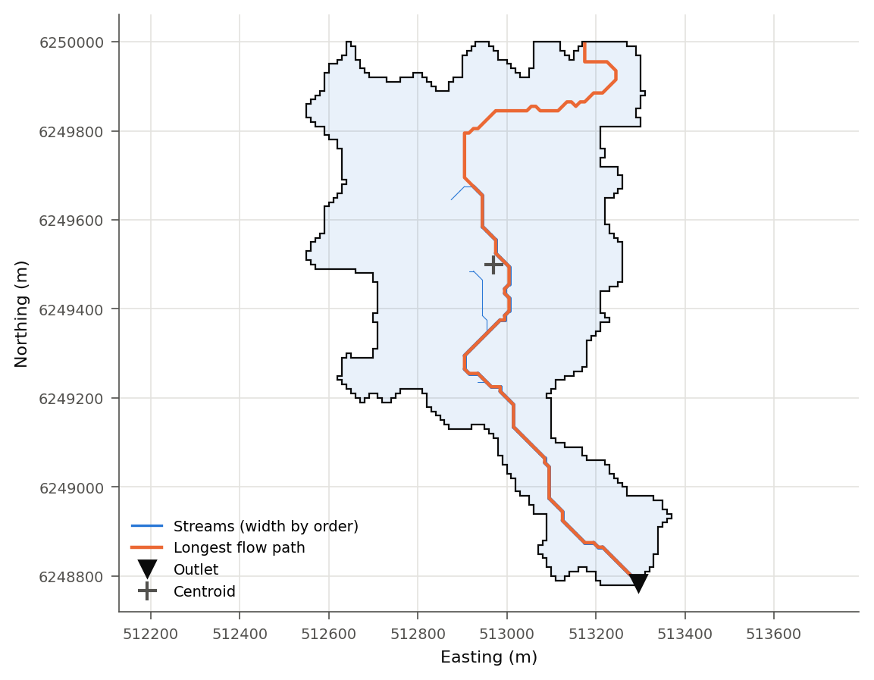
Figure 5: Catchment Tributary T1: outline, stream network, longest flow path, outlet and centroid
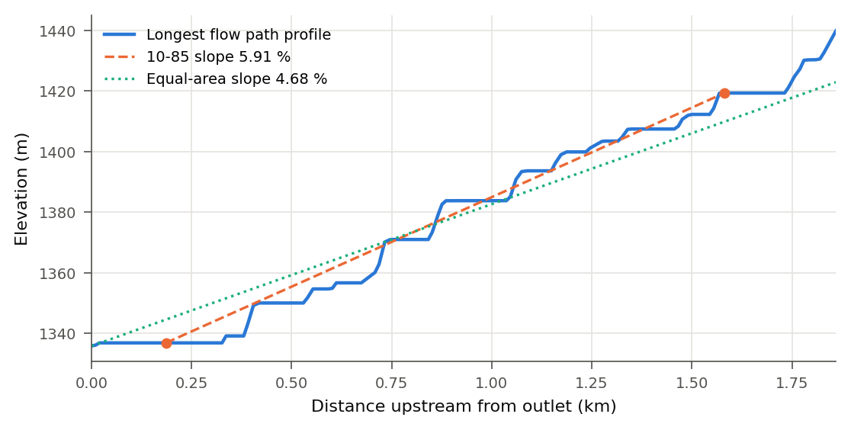
Figure 6: Catchment Tributary T1: longitudinal profile of the longest flow path
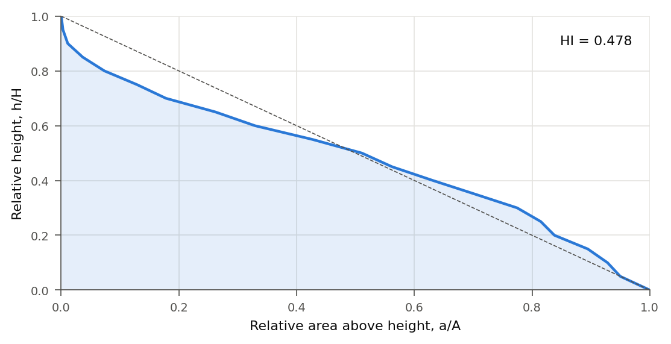
Figure 7: Catchment Tributary T1: hypsometric curve
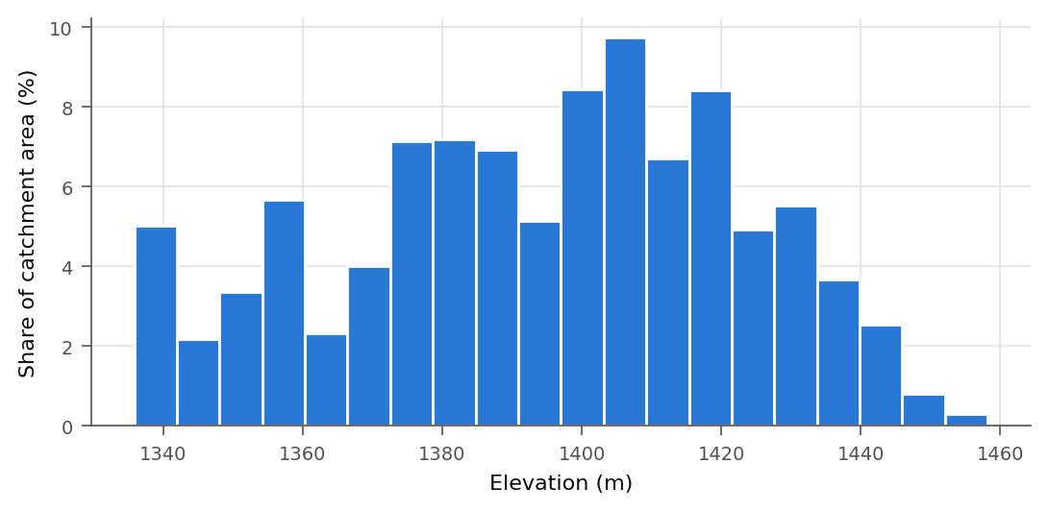
Figure 8: Catchment Tributary T1: elevation distribution

6. Outputs
Table 12: Files produced by the tool
Output | Location
Catchments | D:/Projects/demo/catchments.gpkg
Catchment DEM | D:/Projects/demo/catchment_dem.tif

7. Notes and limitations
- Results are only as good as the DEM. Its resolution, vertical accuracy, vegetation and building artefacts, and hydrological conditioning all control the flow directions and hence the boundary.
- A bare-earth DEM does not contain culverts, bridges, pipes or diversions. Where these exist, check the boundary against site information.
- D8 routing sends all flow from a cell to one neighbour and cannot represent flow splitting (e.g. on fans or flat ground).
- Stream network parameters depend on the chosen stream threshold and the DEM resolution.
- Time-of-concentration values are empirical estimates for guidance; the design method and parameters should follow the governing local guideline.

8. References
Bransby-Williams, G. (1922). Flood discharge and the dimensions of spillways in India. The Engineer, 134, 321-322.
FAO (2006). Guidelines for Soil Description, 4th edition. Food and Agriculture Organization of the United Nations, Rome.
Gravelius, H. (1914). Flusskunde. Göschen, Berlin.
Horn, B.K.P. (1981). Hill shading and the reflectance map. Proceedings of the IEEE, 69(1), 14-47.
Horton, R.E. (1932). Drainage-basin characteristics. Transactions of the American Geophysical Union, 13, 350-361.
Horton, R.E. (1945). Erosional development of streams and their drainage basins. Geological Society of America Bulletin, 56, 275-370.
Kirpich, Z.P. (1940). Time of concentration of small agricultural watersheds. Civil Engineering, 10(6), 362.
Melton, M.A. (1965). The geomorphic and paleoclimatic significance of alluvial deposits in southern Arizona. Journal of Geology, 73, 1-38.
Miller, V.C. (1953). A quantitative geomorphic study of drainage basin characteristics in the Clinch Mountain area, Virginia and Tennessee. Technical Report 3, Columbia University, New York.
O'Callaghan, J.F. & Mark, D.M. (1984). The extraction of drainage networks from digital elevation data. Computer Vision, Graphics, and Image Processing, 28, 323-344.
Pike, R.J. & Wilson, S.E. (1971). Elevation-relief ratio, hypsometric integral, and geomorphic area-altitude analysis. Geological Society of America Bulletin, 82, 1079-1084.
Ponce, V.M. (1989). Engineering Hydrology: Principles and Practices. Prentice Hall, Englewood Cliffs, NJ.
Schumm, S.A. (1956). Evolution of drainage systems and slopes in badlands at Perth Amboy, New Jersey. Geological Society of America Bulletin, 67, 597-646.
Strahler, A.N. (1952). Hypsometric (area-altitude) analysis of erosional topography. Geological Society of America Bulletin, 63, 1117-1142.
Strahler, A.N. (1957). Quantitative analysis of watershed geomorphology. Transactions of the American Geophysical Union, 38(6), 913-920.
Strahler, A.N. (1958). Dimensional analysis applied to fluvially eroded landforms. Geological Society of America Bulletin, 69, 279-300.
Strahler, A.N. (1964). Quantitative geomorphology of drainage basins and channel networks. In V.T. Chow (ed.), Handbook of Applied Hydrology, Section 4-II. McGraw-Hill, New York.
USBR (1973). Design of Small Dams, 2nd edition. United States Bureau of Reclamation, Washington DC.
USDA-NRCS (2007). National Engineering Handbook, Part 630 Hydrology, Chapter 16: Hydrographs. United States Department of Agriculture.
Wilford, D.J., Sakals, M.E., Innes, J.L., Sidle, R.C. & Bergerud, W.A. (2004). Recognition of debris flow, debris flood and flood hazard through watershed morphometrics. Landslides, 1, 61-66.

